Planet Pamishan

Scientists have discovered some new creatures on planet Pamishan. They need your help to identify and classify them. Use the dichotomous key on the next page to identify these creatures and write the names beneath each picture.

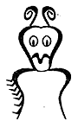 | 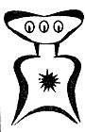 | 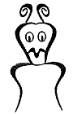 | 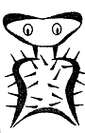 | 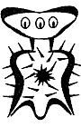
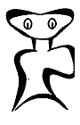 | 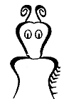 | 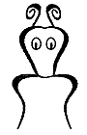 | 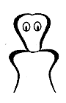 | 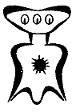
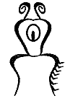 | 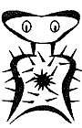 | 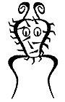 | 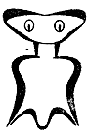 | 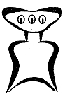
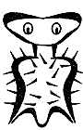 | 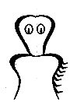 | 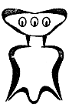 | 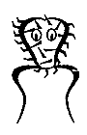 | 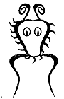

A Key to Pamishan Creatures

- a. The creature has a wide head................................. go to 2
b. The creature has a narrow head............................... go to 11

- a. It has 3 eyes................................................ go to 3
b. It has 2 eyes................................................ go to 7

- a. There is a star in the middle of its chest................... go to 4
b. There is no star in the middle of its chest.................. go to 6

- a. The creature has hair spikes.......................... Broadus hairus
b. The creature has no hair spikes.............................. go to 5

- a. The bottom of the creature is arch-shaped............. Broadus archus
b. The bottom of the creature is M-shaped................. Broadus emmus

- a. The creature has an arch-shaped bottom............... Broadus plainus
b. The creature has an M-shaped bottom.................. Broadus tritops

- a. The creature has hairy spikes................................ go to 8
b. The creature has no spikes................................... go to 10

- a. There is a star in the middle of its body........ Broadus hairystarus
b. There is no star in the middle of its body................... go to 9

- a. The creature has an arch-shaped bottom............. Broadus hairyemmus
b. The creature has an M-shaped bottom................... Broadus kiferus

- a. The body is symmetrical............................... Broadus walter
b. The body is not symmetrical.......................... Broadus anderson

- a. The creature has no antennae................................. go to 12
b. The creature has antennae.................................... go to 14

- a. There are spikes on the face.......................... Narrowus wolfus
b. There are no spikes on the face.............................. go to 13

- a. The creature has no spikes anywhere.................. Narrowus blankus
b. There are spikes on the right leg................ Narrowus starboardus

- a. The creature has 2 eyes...................................... go to 15
b. The creature has 1 eye............................... Narrowus cyclops

- a. The creature has a mouth..................................... go to 16
b. The creature has no mouth.................................... go to 17

- a. There are spike on the left leg....................... Narrowus portus
b. There are no spikes at all........................... Narrowus plainus

- a. The creature has spikes...................................... go to 18
b. The creature has no spikes......................... Narrowus georginia

- a. There are spikes on the head................................. go to 19
b. There are spikes on the right leg.................. Narrowus montanian

- a. There are spikes covering the face................... Narrowus beardus
b. There are spikes only on the outside of the head...... Narrowus fuzzus

